# **Exercise: Smart Wallet Part 2**

## **Register USER in DB**

Your task is to insert a user in the DB for testing purposes since we do not have State Management. Consider implementing a **User** initialization method.

## **Index pages**

Get the index page, next we have to add Thymeleaf for the login and register buttons. Define paths to:

#### **Index**

* Location: **/**
* HTML Template: **index.html**

#### **Login**

* Location: **/login**
* HTML Template: **login.html**

#### **Register**

* Location: **/register**
* HTML Template: **register.html**

### **Home**

* Location: **/home**
* HTML Template: **home.html**

## **Home page with user details**

Home page with user details. Populate the information with Thymeleaf.

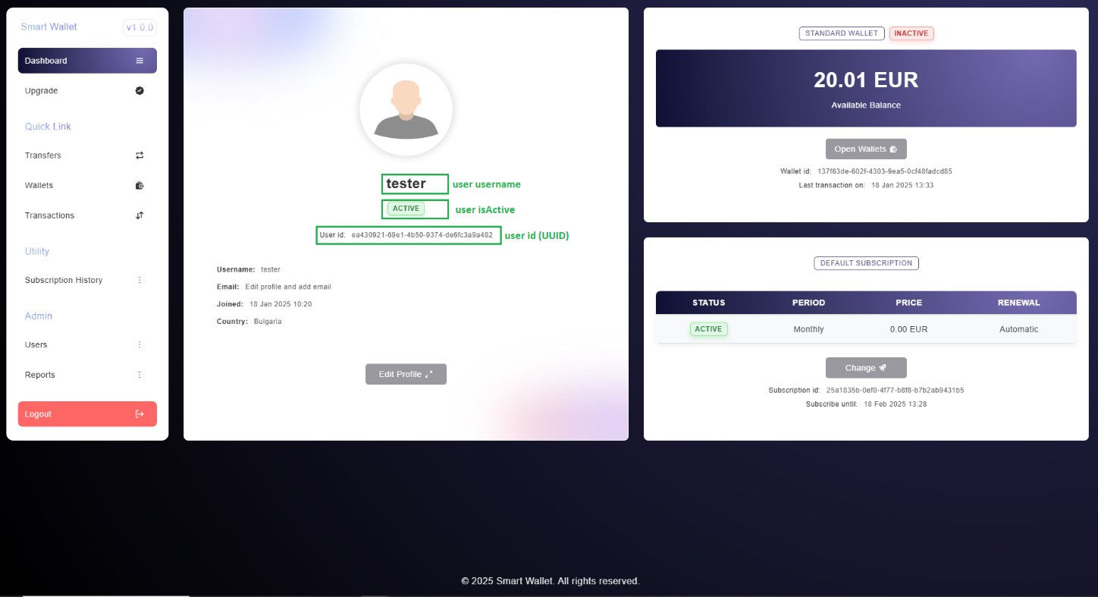

## **Home page buttons**

You have to make **GET** requests to the following endpoints:

### **Edit Profile button**

This button has to send a **GET** request to:

* Location: **/users/{id}/profile**
* HTML Template: **profile-menu.html**

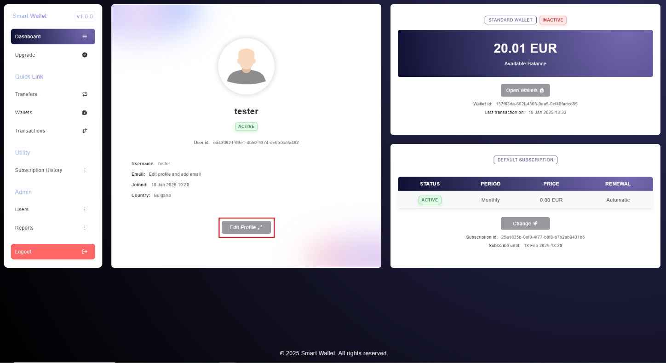

### **Open Wallets button**

This button has to send a **GET** request to:

* Location: **/wallets**
* HTML Template: **wallets.html**

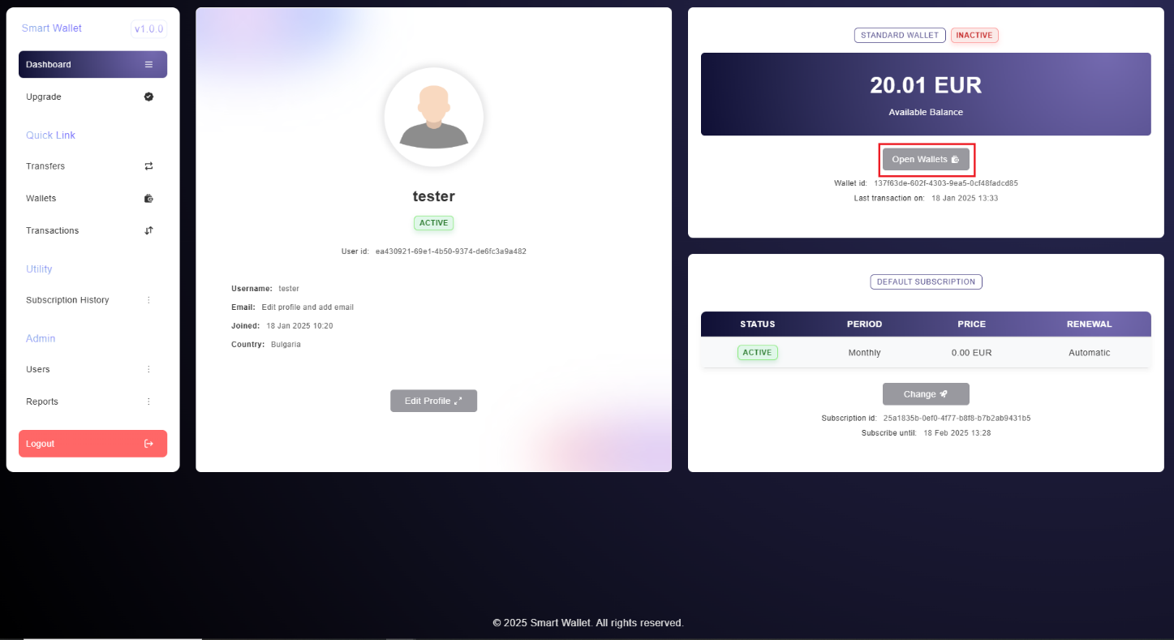

### **Change button**

This button has to send a **GET** request to:

* Location: **/subscriptions**
* HTML Template: **upgrade.html**

## **Subscriptions history Page**

To **GET** **User** subscriptions. Populate the information with Thymeleaf.

* Location: **/subscriptions/history**
* HTML Template: **subscription-history.html**

## **Additional Tasks**

### **Users Page**

To **GET** users page. Populate the information with Thymeleaf.

* Location: **/users**
* HTML Template: **users.html**

### **Reports Page**

To **get** **User** reports. Populate the information with Thymeleaf.

* Location: **/reports**
* HTML Template: **reports.html**

### **Transactions Page**

To **get** User transactions. Populate the information with Thymeleaf.

* Location: **/transactions**
* HTML Template: **transactions.html**

